EXP NO:7
Aim
Capture live webcam video using OpenCV and display.
Algorithm
- Import OpenCV library for webcam video capturing.
- Open default webcam using VideoCapture zero function.
- Capture webcam frames continuously inside while loop.
- Display captured frames using OpenCV imshow function.
- Press q key to stop webcam capture.
- Release webcam and close all display windows.
Code
import cv2

cap = cv2.VideoCapture(0)

while True:
ret, frame = cap.read()

if not ret:
break

cv2.imshow("Slow Motion", frame)

if cv2.waitKey(100) & 0xFF == ord('q'):
break

cap.release()
cv2.destroyAllWindows()
Output:
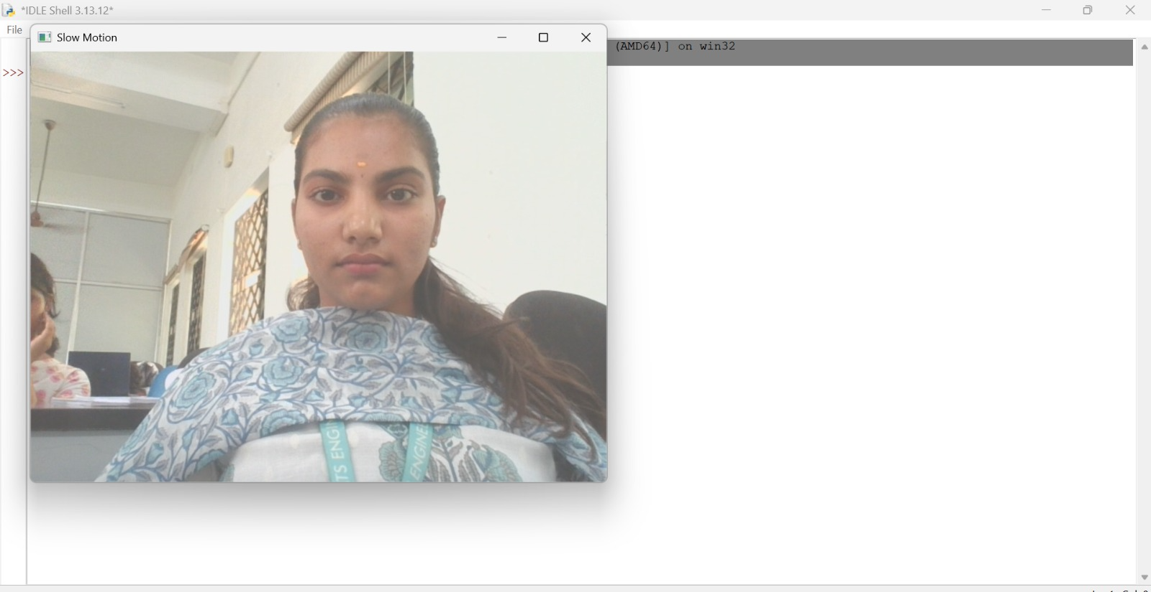

Result
The live webcam video was successfully captured and displayed. The program stopped when the 'q' key was pressed.

